CS162 ASSIGNMENT 2

NAME:

ARCHIT AGRAWAL

ROLL NO. :

202052307

SECTION:

A

***ASSIGNMENT – 2: QUESTIONS***

1. Reverse a given integer.

Ex. - Input: 7458965

Output:- 5698547

2. Remove duplicate letters from string and return the new string with all unique characters

in lexicological order.

Ex. - Input: “DataStructure”

Output:- “DatSruce”

3. Implement strstr() i.e. return the index of first occurrence of substring if present

otherwise return -1.

Ex. - Input: “DataStructure”, “tru”

Output: 5

Ex. - Input: “DataStructure”, “true”

Output: -1

4. Count no. of zeros at the end of n! i.e. (n factorial).

Ex. - Input: 5 (5! = 5*4*3*2*1 = 120)

Output:- 1

5. Count the number of ‘1’ bits in binary string.

Ex. - Input: “1010101”

Output:- 4

6. Valid email address (must contain “@” symbol) i.e. return True if email address is valid

otherwise return False.

Ex. - Input: 2020@.gmail.com

Output:- False

Ex. - Input: 2020@iiitvadodara.ac.in

Output:- True

7. String to integer (including cases like “00123”)

Ex. - Input: “0124510”

Output:- 124510

8. Given a string s and an integer k, reverse the string in batches of k.

Ex. - s=”abcdefgh” ; k = 3 ; return “cbafedgh”

Ex. - s=”abcdefghi” ; k = 3 ; return “cbafedihg”

9. Determine if two strings are isomorphic. Two strings s and t are isomorphic if the

characters in s can be replaced to get t

Input: s = "egg", t = "add"

Output: True (replace e -> a and g -> d)

Input: s = "foo", t = "bar"

Output: False

Input: s = "paper", t = "title"

Output: True

10. Pattern: Inverted Pyramid

* * * * * * * * *

* * * * * * *

* * * * *

* * *

*

## Creating a class named Main and defining the Methods listed below in it (methods are numbered corresponding to the questions)

1. long reverseInteger (long a);
2. String removeDuplicate (String s);
3. int checkSubString(String str1, String str2);
4. int zeroInFactorial(int a);
5. int count1(String str);
6. boolean isValidEmail(String email);
7. long strToInt(String s);
8. String revStringInK(String s, int k);
9. boolean isIsomorphic(String s, String s1);

10.void invertedPyramid(int rows);

CODE:

//package com.company

//if running on an online compiler there is no need to uncomment the first

//line, else if running on IntelliJ then uncomment the first line before

//executing

import java.util.*;  
  
public class Main {  
  
 public static long reverseInteger(long a){  
  
 long rev_a = 0;  
 while(a != 0){  
 int digit = (int) (a % 10);  
 rev_a = rev_a * 10 + digit;  
 a = a/10;  
 }  
 return rev_a;  
 }  
  
 public static String removeDuplicate(String s) {  
 if(s == null) return "String does not contain any character";  
 String n_str = "";  
 for (int i = 0; i < s.length(); i++) {  
 int count = 0;  
 for (int j = 0; j < n_str.length(); j++) {  
 if (n_str.charAt(j) == s.charAt(i)) count++;  
 }  
 if (count == 0){  
 n_str = n_str + s.charAt(i);  
 }  
 }  
 return n_str;  
 }  
  
 public static int checkSubString(String str1, String str2){  
 if(str1.length() < str2.length()) return -1;  
 int k, count;  
 for(int i = 0; i < str1.length(); i++){  
 if(str1.charAt(i) == str2.charAt(0)){  
 k = i;  
 count = 0;  
 i++;  
 for(int j = 1; j < str2.length(); j++){  
 if(str1.charAt(i) == str2.charAt(j)){  
 count++;  
 i++;  
 }  
 }  
 if(count == str2.length() - 1) return k;  
 }  
 }  
 return -1;  
 }  
  
 public static int zeroInFactorial(int a){  
  
 int c = 5;  
 int count = 0;  
 while(a/c != 0){  
 count += a/c;  
 c *= 5;  
 }  
 return count;  
 }  
  
 public static int count1(String str){  
 if(str == null) return -1;  
 int count = 0;  
 for(int i = 0; i < str.length(); i++){  
 if(str.charAt(i) == '1') count++;  
 }  
 return count;  
 }  
  
 public static boolean isValidEmail(String email){  
 int count = 0;  
 for(int i = 0; i < email.length(); i++){  
 if(email.charAt(i) == '@'){  
 count++; //to check if there are multiple @  
 }  
 }  
 if(count != 1) return false;  
  
 int flag = 0;  
 for(int i = 0; i < email.length(); i++){  
 if(email.charAt(i) >= 65 && email.charAt(i) <= 90){  
 flag = 0;  
 } else if(email.charAt(i) >= 97 && email.charAt(i) <= 122){  
 flag = 0;  
 } else if(email.charAt(i) >= 48 && email.charAt(i) <= 57){  
 flag = 0;  
 }  
 else if(email.charAt(i) == '_' || email.charAt(i) == '.' || email.charAt(i) == '-' || email.charAt(i) == '@'){  
 flag++;  
 if(flag > 1) return false; //if two continuous characters are special characters, the email is invalid  
 if(i == 0 || i == email.length() - 1) return false; //first and last character cannot be a special character  
 }  
 else return false;  
 }  
 return true;  
 }  
  
 public static long strToInt(String s){  
 if(s == null) return -1;  
 long num = 0, c = 1;  
  
 for(int i = (s.length() - 1); i >= 0; i--){  
 num = c * ((int)s.charAt(i) - 48) + num;  
 c *= 10;  
 }  
 return num;  
 }  
  
 public static String revStringInK(String s, int k){  
 if(s == null) return "Invalid String";  
 String rev_str = "";  
 int i = 1;  
 while(true){  
 if(i * k <= s.length()){  
 for(int j = i * k - 1; j >= k * (i - 1); j--){  
 rev_str = rev_str + s.charAt(j);  
 }  
 } else {  
 for(int j = k * (i - 1); j < s.length(); j++){  
 rev_str = rev_str + s.charAt(j);  
 }  
 break;  
 }  
 i++;  
 }  
 return rev_str;  
 }  
  
 public static boolean isIsomorphic(String s, String s1){  
  
 if(s.length() != s1.length()) return false;  
  
 char[] visited = new char[26];  
 for(int i = 0; i < 26; i++){  
 visited[i] = '*';  
 }  
 for(int i = 0; i < s.length(); i++){  
 char ch = visited[s.charAt(i) - 'a'];  
 if(ch == '*'){  
 visited[s.charAt(i) - 'a'] = s1.charAt(i);  
 } else if (ch != s1.charAt(i)){  
 return false;  
 }  
 }  
 return true;  
 }  
  
 public static void invertedPyramid(int rows){  
  
 for(int i = 0; i < rows; i++){  
 for(int j = 0; j < i; j++){  
 System.*out*.print(" ");  
 }  
 for(int j = 2 * rows - 1; j > 2 * i; j--){  
 System.*out*.print("* ");  
 }  
 System.*out*.println();  
 }  
 }  
  
 public static void main(String args[]){  
 Scanner sc = new Scanner(System.*in*);  
 System.*out*.println("Enter an positive integer whose reverse you want to find");  
 long m = sc.nextLong();  
 System.*out*.println("The reverse of "+m +" is : " +*reverseInteger*(m));  
 System.*out*.println();  
 sc.nextLine();  
  
 System.*out*.println("Enter a string to remove duplicate characters from it");  
 String s = sc.nextLine();  
 System.*out*.println("The new string is : "+*removeDuplicate*(s));  
 System.*out*.println();  
  
 System.*out*.println("Enter two strings s and s1 to get the index of first occurrence of s1 in s (-1 if s1 is not a substring of s)");  
 System.*out*.println("Enter string s");  
 s = sc.nextLine();  
 System.*out*.println("Enter string s1");  
 String s1 = sc.nextLine();  
 System.*out*.println("The index of first occurrence of s1 in s is : " +*checkSubString*(s, s1));  
 System.*out*.println();  
  
 System.*out*.println("Enter an integer to calculate the number of zeroes at the end of its factorial");  
 int n = sc.nextInt();  
 System.*out*.println("No. of zeroes at the end of "+n +"! are : "+ *zeroInFactorial*(n));  
 System.*out*.println();  
 sc.nextLine();  
  
 System.*out*.println("Enter a binary string (containing 0's and 1's)");  
 s = sc.nextLine();  
 System.*out*.println("No. of 1's in the input string are : "+ *count1*(s));  
 System.*out*.println();  
  
 System.*out*.println("Enter an email address to check if it is a valid email address or not (format wise only)");  
 s = sc.nextLine();  
 if(*isValidEmail*(s)) System.*out*.println("The email address " +s +" is valid.");  
 else System.*out*.println("The email address "+s +" is invalid.");  
 System.*out*.println();  
  
 System.*out*.println("Enter a numeric string to convert it into an integer");  
 s = sc.nextLine();  
 System.*out*.println("The integer corresponding to the input string is : "+*strToInt*(s));  
 System.*out*.println();  
  
 System.*out*.println("Enter a string to reverse it in batches of k");  
 s = sc.nextLine();  
 System.*out*.println("Enter integer k");  
 int k = sc.nextInt();  
 System.*out*.println("The original string is : "+s);  
 System.*out*.println("The string reversed in batches of k is : "+*revStringInK*(s, k));  
 System.*out*.println();  
 sc.nextLine();  
  
 System.*out*.println("Enter two strings s and s1 to check if they are isomorphic to each other or not");  
 System.*out*.println("Enter string s");  
 s = sc.nextLine();  
 System.*out*.println("Enter string s1");  
 s1 = sc.nextLine();  
 if(*isIsomorphic*(s, s1)) System.*out*.println("The two strings are isomorphic to each other.");  
 else System.*out*.println("The two strings are not isomorphic to each other.");  
  
 System.*out*.println("Enter number of rows");  
 n = sc.nextInt();  
 *invertedPyramid*(n);  
  
 }  
}

OUTPUT:

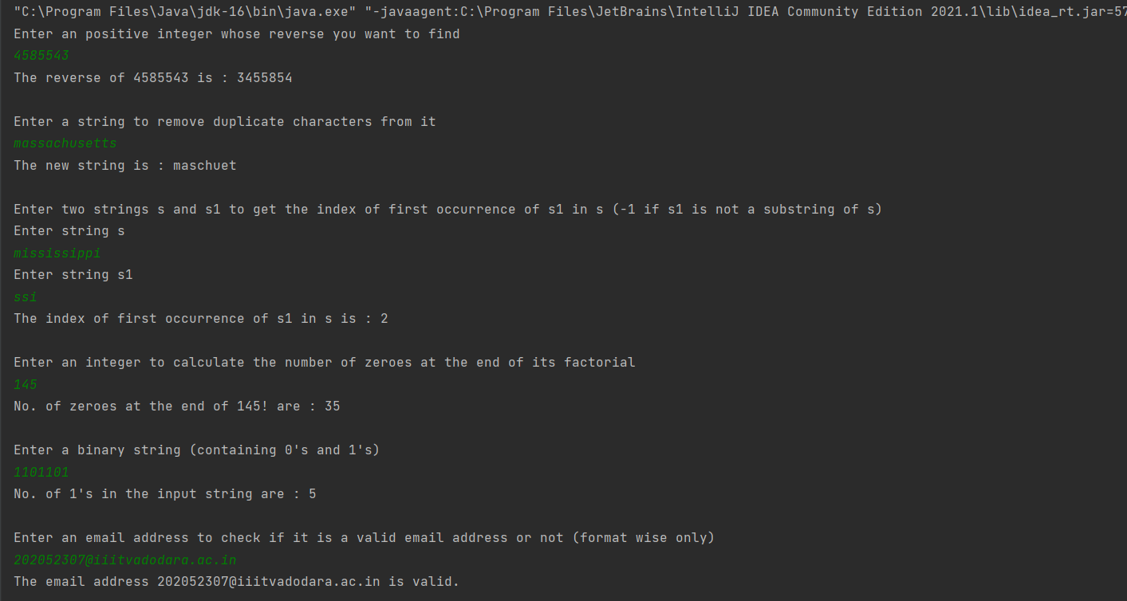

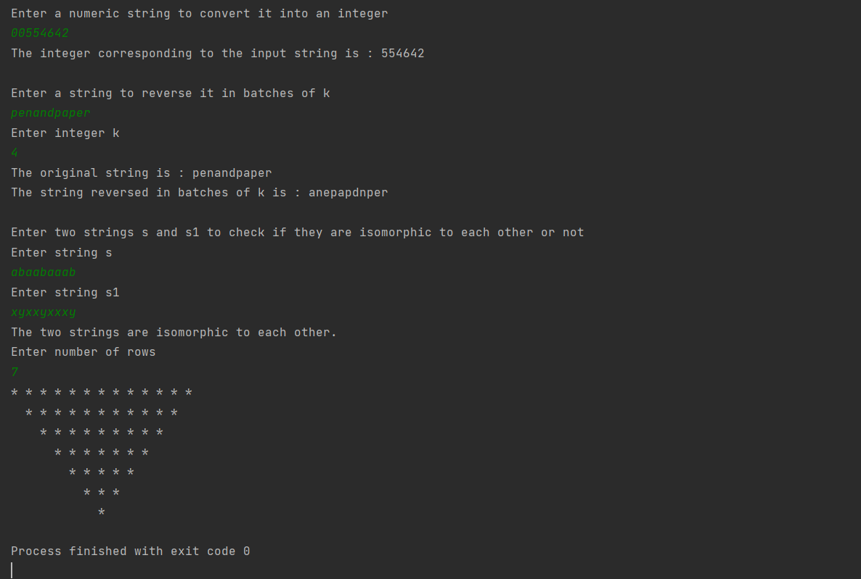

**Alternative Outputs for a few methods**

